CURRICULUM VITAE

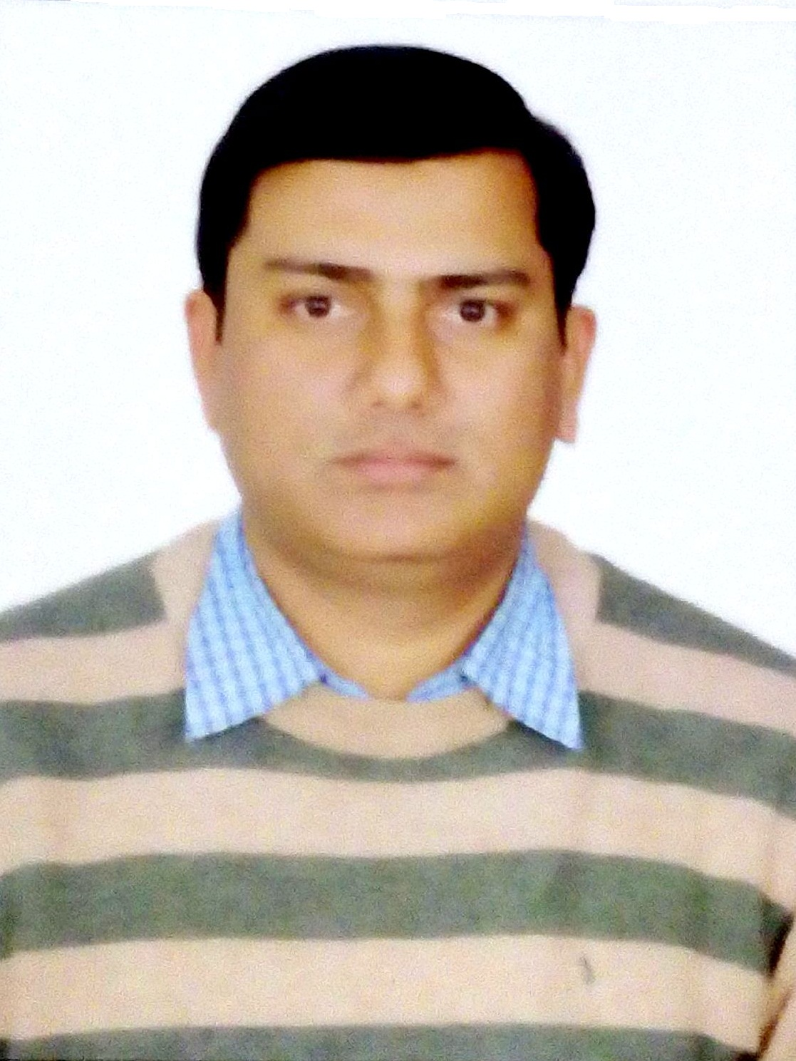
MOHD.BILAL
D-67, First Floor, Shaheen Bagh, Okhla, Jamia Nagar, New Delhi-25
# 9891708055, 8750337835 Email: bilallookman@gmail.com

OBJECTIVE

Seeking a Human Resources Management position where my professional experience and education will allow me to make an immediate contribution as an integral part of a progressive company. Wishing to apply my business experience and education to assist the company in the accomplishment of its goals.

PROFESSIONAL SYNOPSIS
- A dedicated and result oriented HR Professional with a strong academic background and more than 10 years of relevant experience in Recruitment & HR Generalist Profile.
- Admirable exposure to Human Resource Management, Recruitment and Selection, Training & Development, Performance Management, Manpower Planning, Compensation Benefits, Employee Relations, Payroll Management etc.
AREAS OF EXPERTISE:
- Human Resource Planning, Talent Acquisition & Resource management
- Employee Engagement, Employee Retention & Employee Relations
- Payroll Management, Orientation & On-Boarding

Compensation & Benefit/ Compliances

Salary process

HR Policy Execution

Full & final Settlement & Existing Interview
EMPLOYMENT HISTORY

From July 2017 till Date Working with H.R. International (Group of Companies) as a Manager-HR
H.R International, Certified Manpower Consultancy and a leading entity owned by H.R Group of Companies.

Job Responsibilities:

Talent Acquisition & Selection
- Preparing manpower plan & budget according to project requirement.
- Managing the entire recruitment cycle.
- Resource Database management, pipeline resourcing, critical resource identification and resourcing and Ensuring the availability of Manpower as per budget and TAT.
- Identifying potential candidates through various channels viz., job portals, social network sites like LinkedIn, referrals, Walk in Interviews, Head Hunting etc.
- Coordination with client and operation team for mobilization of manpower
- Manpower Monitoring and reports / MIS generation
- Bench Marking and Industry survey
- Advertisement, Walk-In, Internal resume databank management through resume fox.
Training and Development
Designing training calendar with TNI Inputs as per Training Procedure, ensuring implementation of the training calendar for the year, calculating satisfaction index. Training Effectiveness and feedback analysis.
Performance Management

- Handling entire performance review process for the designated discipline
- Establishing the framework for performance counseling and achieving the congruence in identifying the individual career paths in the organizational plans
- Conducting appraisal meetings and handling any issues thereof
Business Support
- Providing manpower, administration cost analysis to business development team before biding of projects.
- Strategic planning with Costing and BD department at the time of biding and tendering.
- Meeting with clients for smooth deployment and solve problems related to mobilization / demobilization and statutory issues.
HR Analytics
- Handling a critical area of HR Business Analysis having complete hold of information for the management.
Provide quantitative and qualitative analytical support by drawing meaningful conclusions/ insights from the data and presenting these observations to senior management. Site Manpower mobilization/ demobilization / termination/ Administrative
- Implementation of employee deployment and mobilization plans as per number and time schedule with all the relevant status reports.
- Demobilization plans as per number and time schedule with all the relevant status reports.
- Ensuring all the necessary required process to be followed during Deployment / Transfer / Resignation / Absconding / Termination cases with all the records maintained.
- Consolidating site level grievances related to Admin and resolution as per set time lines
- Handling all administrative discipline cases of sites and HO and taking corrective actions.
Compliance
- Ensuring Statutory Compliance with regards to various Labour Laws e.g. Contract Labour Act, Payment of Wages Act, Minimum Wages Act, Bonus Act, Gratuity Act and Contract Labour Act etc.
- Compliance with regards to ESIC and Provident Fund.
- Complying with the provisions of various labour legislations & filing of various returns under labour laws.
Induction & Orientation programs
Responsible for arranging induction and orientation programs for new employees rehabilitated in the changed surrounding and introduced to the practices, policies, purposes and people of the organization.
Policies & Procedures
- Implementation and ensuring adherence of HR policies and practices, as defined.
- Communicating policies, update employee manuals.
- Involved in the implementation of HR Functions/Manuals/Policies & Procedures.
Welfare Programs / Employee Engagement
- Festive occasions, annual day celebrations, employee engagement and cultural events.
- Grievance Handling &Counseling of the employees.

Deusch Kyosei Engineering Private limited (Noida) August-2015 till June-2017
Designation: HR-Manager

(Deusch Kyosei Engineering Pvt.Ltd. a joint venture company with Kyosei Japan is one of the leading global manufacturers of high quality control cables for automobiles, construction, and agriculture machinery.
Recruitment:
Involved in recruitment of Middle level/senior positions and critical expert profile for India and Seoul office Reference check of candidates to ensure their authenticity and Document verification.
Induction & Orientation:
Responsible for arranging induction and orientation programs for new employees rehabilitated in the changed surrounding and introduced to the practices, policies, purposes and people of the organization.
Training & Development:
Designing training calendar with TNI Inputs as per Training Procedure, ensuring implementation of the training calendar for the year, calculating satisfaction index. Training Effectiveness and feedback analysis.
Strategy Planning & Policy Formulation:
Developing and implementing strategic plans & HR policies, in line with overall organisational goals. Preparing detailed budgets and manpower plans at the macro level.
Compensation & Benefits:
Implementing various remuneration policies, including pay packages for newly hired employees. Designing salary structure as per organizational requirements and prevailing industry trends. Conducting/ organizing compensation and benefit surveys.
HR Operation
Addressing employee issues on day to day basis, Processing claims for transportation expenses of new joinee. Organizing different Events in Corporate Office & Weekly report for management.

W-Lifestyle India Private Limited, (Westinghouse) 17th Jan -2014 to till Aug-2015

Designation: HR Manager

(A consumers durable electrical products Manufacturing Company of home appliances & Kitchen appliances)

Job Responsibilities:

- Handling the entire recruitment and selection process.

Recruitment, on-boarding and planning human resource requirements in consultation with heads of different functional & operational areas and supervise the recruitment and on-boarding process.

Manage the interview & selection process.
- Responsible to manage and coordinate with consultancies on all the active job requirements.
- Handling Manpower Recruitments by sourcing profiles through advertisements, internal database, references, networking, organizing interviews, selecting and hiring candidates.
- Handling salary negotiation and compensation in line with industry standards.
- Carrying out joining and Induction activities of new candidates.
- Handling attendance, payroll, OD, leave records and overtime records of the employees.
- Handling Employee's personnel record documentation and maintenance, Employee details & Employee family background.
- Taking care of employee grievances
- Undertaking HR initiatives and organizing events
- Handling all Administrative activities like maintenance of Office equipments, housekeeping and maintenance of Office & record keeping of Office stationary including various formats.
- Team handling & maintaining employee’s personal files and database and all the general HR administration, Attendance and leave management process.
- Preparing monthly salary of all employees as per the schedule, cross checking salary file output based on received input file and sending it to accounts team for disbursement.

Updating the Attendance, leave details, Appraisals details, Increment details and Incentive details on payroll software.

Arranging & conducting Interviews/Initial screening the candidates/ coordinating in recruitment processes & training programs.

Prepare and submit all relevant HR letters/ documents/ certificates as per the requirement of employees in consultation with the management

Procuring all the leave applications/ on duty forms for salary process and records.

Maintain the Payroll Management and all statutory compliances records i.e. ESI & PF etc.

Conduct exit interviews for employees and record them accordingly.

Conduct employee orientation and facilitate newcomers joining formalities Maintain and regularly update (personal database) of each employee.

Maintaining Recruitment Data &. Create & update Job Description

2. Lookman Electroplast Industries Ltd. HR-Assistant Manager (North India)
April 1st-2010 to till Oct.-2013 (Deal in CCTV Security systems ‘electronics products)

Job Responsibilities:

- Involved in full recruiting life cycle & end to end recruitment.
- Management and monitoring of all recruitment activities to ensure recruitment deadlines are met as per company policy
- Handling the Selection procedure like screening, scheduling and conducting Interview.
- Established selection procedures, including interviewing, testing and reference, and background checking.
- Day to day Attendance checking & Maintaining Leave Cards of On roll Employees.
- Checking & Maintaining of Overtime & late coming reports, Absenteeism Reports of On-Roll Employees etc.
- Responsible to manage and coordinate with consultancies on all the active job requirements, if necessary.
- Custodian of all HR Policies and Processes
- Responsible for grievance management process and maintain disciplinary standards of the organization.
- Responsible for all the exit formalities including Full and final settlement.
- Effective implementation of Reward and Recognition to appreciate high performers.
- Ensuring Event management on specific occasions thus ensuring Employee Engagement.
- Developed promotional campaigns for attracting best talents from industry, which includes activities such as Campus Hiring, LinkedIn postings, Job Sites (Naukri & Monster), Newspaper advertisements, Employee Referral Programs, Mass Walk-ins, Outstation Recruitment drives, Tie-ups with Training Institutes.

Dr. Shikha’s Nutri- Health Systems Pvt. Ltd- Sr.Executive-HR May’07 to Feb’2010 (Healthcare Company)

- Responsibilities:
- Head hunting through portal, short list the candidate’s resumes for interview.
- Calling the candidates for interview.
- Conduct the Walking Interview.
- Assist in recruitment & selection process.
- Complete the documentation process and verification.
- Arranging the induction program for the new joiners & documentation.
- Handling employees joining & Exit formalities.
- Maintaining the attendance of the employees.
- Calculating & processing the salaries of the employees.
- Taking feedback from previous employers.
- Implementing the talent acquisition strategy by sourcing resumes through a combination of Job Portals, Website, and Referrals & Consultants as per the needs of the organization.
- Screening of profiles, interviewing, selecting, ensured the tracking and organizing of all the applicant data.
- To create personal files and maintain them throughout the lifecycle of the employee.
- Facilitating Exit interviews and providing feedback to the management.
- Regulating and enforcing HR discipline like attendance, working hours etc. and monitor a sound work culture within the organization
- Preparing the Offer letters & Appointment letters for the selected candidates.
- Assisting the HR manager with other HR activities.
- .

QUALIFICATION
- MBA (HR & Marketing ) from Jamia Millia Islamia University 2005-2007 Secured 68%
- PGDHR (Post Graduate Diploma In Human Resource) from JMI University2004 Secured 59%
- M.A. (Political Science) from Jamia Millia Islamia University 2003, secured 65%
- Graduation in B.A (Hon.) from Jamia Millia Islamia University 2001 With 1st Div,secured 62%
- Intermediate from Jamia Senior secondary School New Delhi 1998 With 1st Div,secured 78%
- High School from UP. Board 1995, With Second Division Secured 58%

PERSONAL INFORMATION

- Father’s Name: Mr. Mohd. Intakhab
- Sex: Male
- Marital Status: Married
- Nationality: Indian
- Date of Birth: 01-Jan-1980
- Language Known: Hindi, English & Urdu

STRENGTHS:
- Leading by example
- Professional attitude with mature mind
- Willingness to take challenges outside the comfort zone.

- I hereby declare that the information furnished above is true & best of my knowledge.

Date:
Place: (MOHD.BILAL)

